# Experiment 2

**AIM**: Configure IP address to routers in packet tracer. Explore the following messages: ping responses, destination unreachable, request timed out, reply

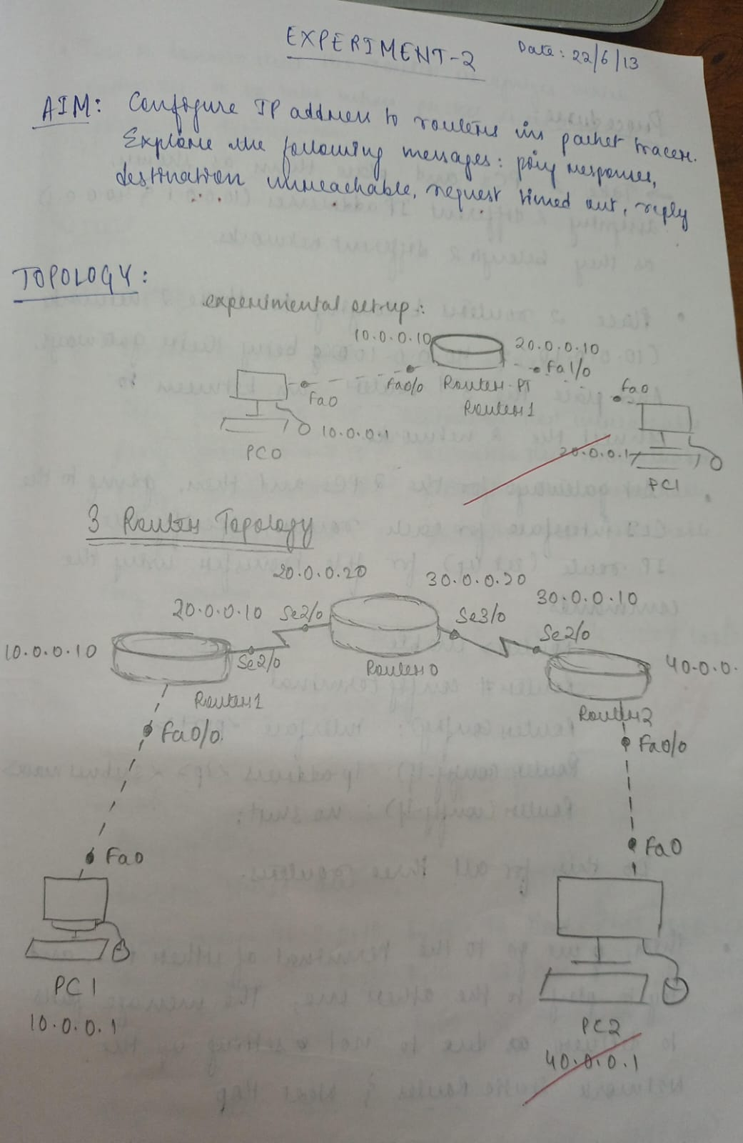

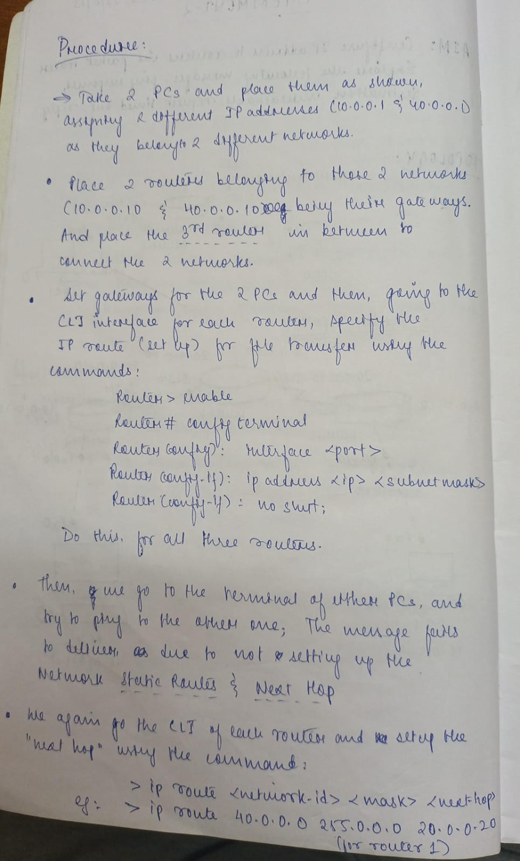

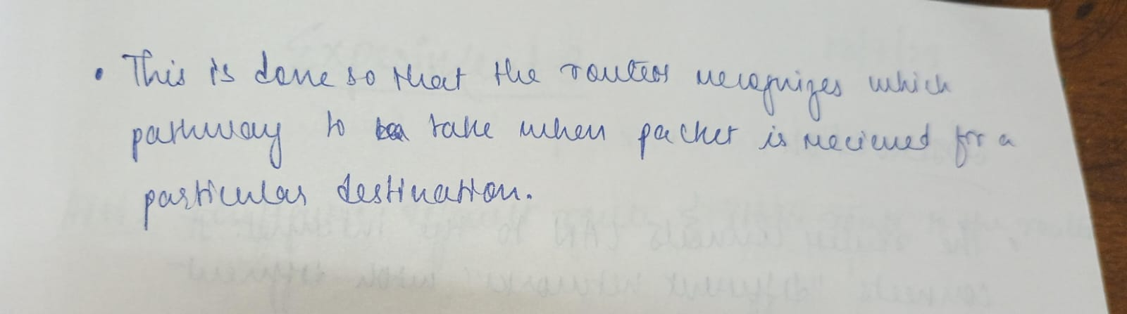

# OUTPUT :

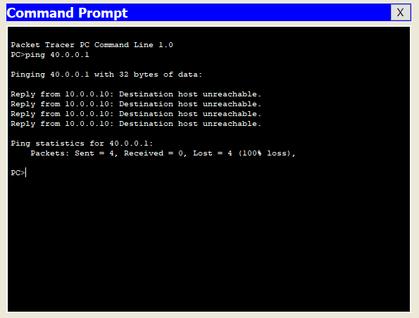

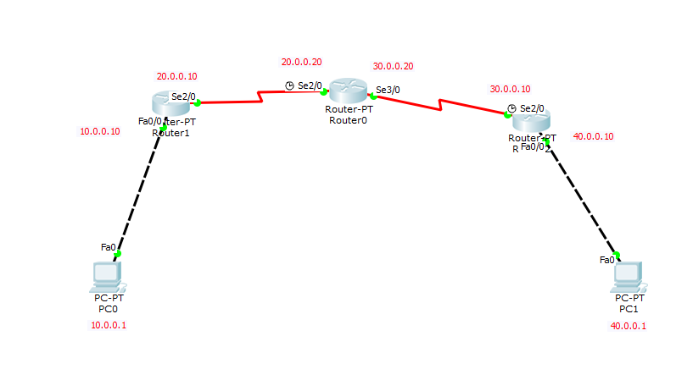

**OBSERVATION**:

